1. **What do you understand By Database.**

* A database is an organized collection of structured information, or data, typically stored electronically in a computer system. A database is usually controlled by a database management system (DBMS).

1. **What is Normalization?**

* Normalization is the process of organizing data in a database. Normalization is an essential part of product information management, preventing data from being replicated in two tables at the same time or unrelated product data being gathered together in the same table.

1. **What is Difference between DBMS and RDBMS?**



|  |  |
| --- | --- |
| **DBMS** | **RDBMS** |
| - DBMS stands for Database Management System | - RDBMS is the acronym for the Relational Database Management system |
| -IN DBMS, the data is stored as a file | - IN RDBMS, data is stored in the form of tables. |
| - DBMSsupports a sigle user | **-**RDBMSsupports multiple user |
| **-**xml, Microsoft Access. | - Oracle, SQL server. |

1. **What is MF Cod Rule of RDBMS Systems?**

* This rule states that for a system to qualify as an RDBMS, it must be able to manage database entirely through the relational capabilities.

1. **Whatdo you understand By Data Redundancy?**

* Data redundancy occurs when the same piece of data exists in multiple places, whereas data inconsistency is when the same data exists in different formats in multiple tables. Unfortunately, data redundancy can cause data inconsistency, which can provide a company with unreliable and/or meaningless information.

1. **What is DDL Interpreter?**

* DDL expands to Data Definition Language. DDL Interpreter as the name suggests interprets the DDL statements such as schema definition statements like create, delete, etc. The result of this interpretation is a set of a table that contains the meta-data which is stored in the data dictionary.

1. **What is DML Compiler in SQL?**

* A DML (data manipulation language) refers to a computer programming language that allows you to add (insert), delete (delete), and alter (update) data in a database. Represents a collection of programming languages explicitly used to make changes to the database.

1. **What is SQL Key Constraints writing an Example of SQL Key Constraints.**

* SQL constraints are used to specify rules for the data in a table. Constraints are used to limit the type of data that can go into a table. This ensures the accuracy and reliability of the data in the table. If there is any violation between the constraint and the data action, the action is aborted.

1. **What is save Point? How to create a save Point write a Query?**

* Save pointis a command in SQL that is used with the rollback command.The syntax for a SAVEPOINT command is as shown below. SAVEPOINT SAVEPOINT_NAME; This command serves only in the creation of a SAVEPOINT among all the transactional statements.

1. **What is trigger and how to create a Trigger in SQL?**

* A trigger is a special type of stored procedure that automatically runs when an event occurs in the database server. DML triggers run when a user tries to modify data through a data manipulation language (DML) event. DML events are INSERT, UPDATE, or DELETE statements on a table or view. Syntax : Create trigger [ trigger_ name].

1. **Create Table Name : Student and Exam**

**Table student:-**

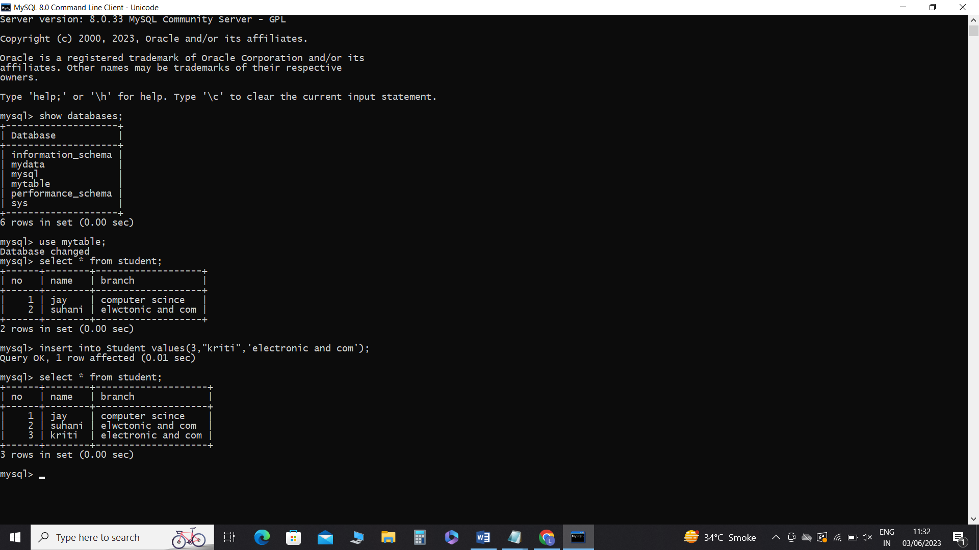

**Table exam:-**

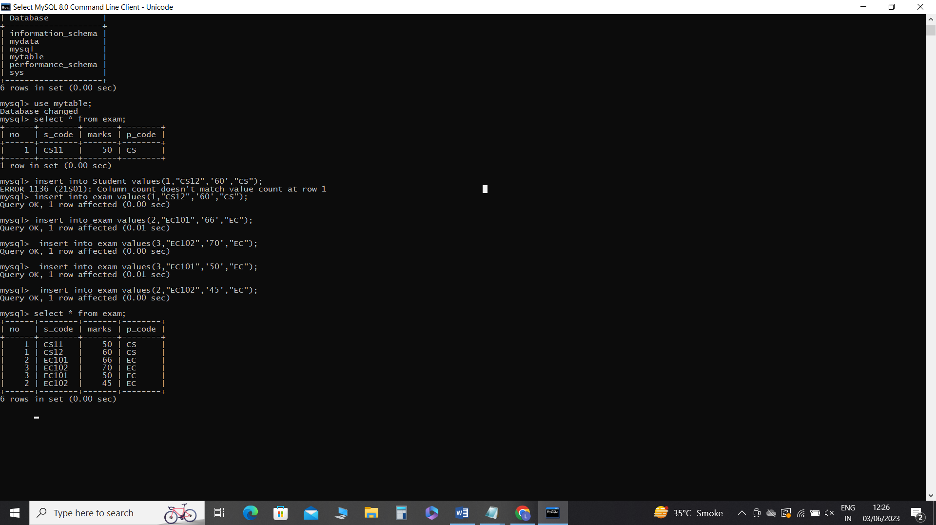

**2.Create table given below:**

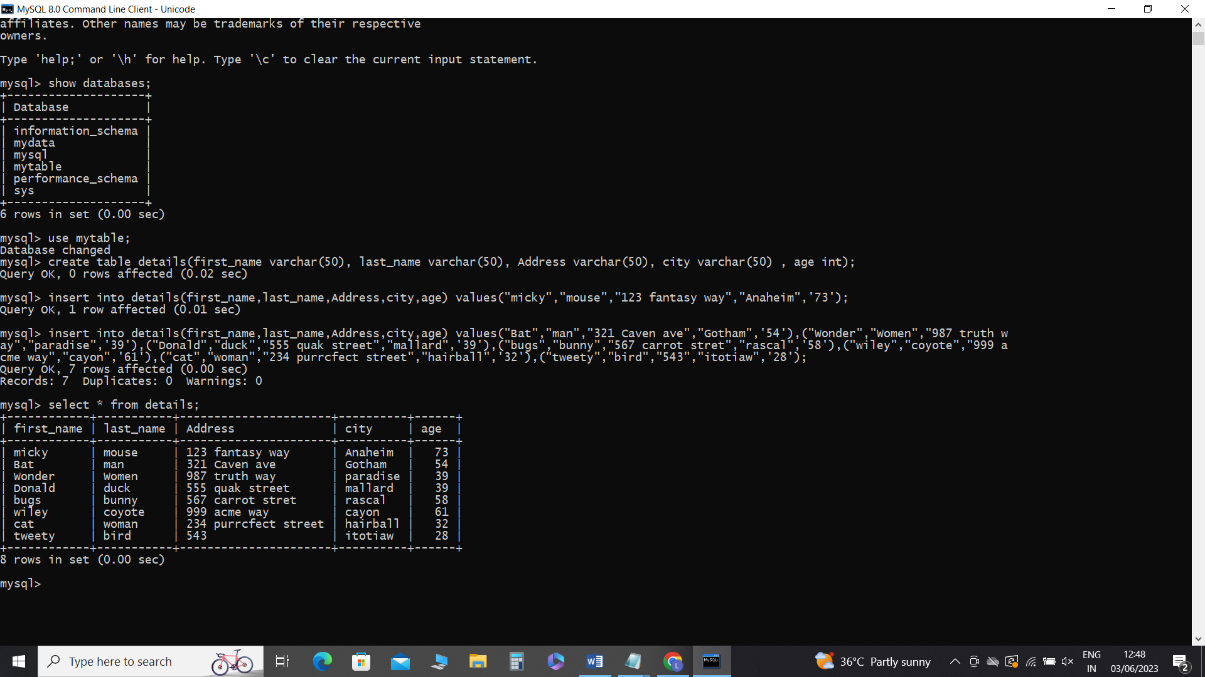

**1.Create table given below: Employee and Incentive**

**Table Name: Employee**